Introduction

Purpose and Scope
The purpose of Target Modifier Plug-In API is to provide a plug-in interface for modifying targets according to customer specific needs. A target is a logical subpart of a HW resource. E.g. lights resource has primary display and primary keyboard targets, in addition to others. In Symbian OS v9.4 only light target modification is supported and a target is for example a led, a display backlight, etc. Target modifying enables context-specific controlling and modification of targets; it is possible to control and modify targets according to the state of the device and according to the activation status of the targets.

API description
Target Modifier Plug-in API of HW Resource Manager is an ECom API defining a virtual base class from which HWRM Target Modifier Plug-in implementation must be derived.
HW Resource Manager is a client-server solution, which utilizes ECom plug-ins to achieve device independency. HW Resource Manager provides client APIs for controlling lights and vibra of the device. It also has additional responsibility of publishing certain power state related Publish & Subscribe properties. For more information, see reference documents [1]-[6].
HWRM Target Modifier Plug-in is a plug-in module that is responsible for device specific target modification according to target activation status. The plug-in is loaded via the ECom mechanism. At startup HW Resource Manager Server initializes HWRM Target Modifier Plug-in for lights. When turning lights on or off, or making them blink currently inactive (i.e. covered or otherwise hidden or just not active for other reasons) targets are stripped from the target using HWRM Target Modifier Plug-in.
The plug-in is not mandatory for HWRM functionality, but the light control logic will be broken if the plug-in is dropped from the image. If the HWRM Target Modifier Plug-in is missing, targets are never modified. Symbian OS provides a reference implementation for HWRM Target Modifier Plug-in that may be customised as required. Alternatively, customers desiring custom functionality can simply replace the entire plug-in.
The type of the interface is a synchronous method call. All functionality is accessed through the abstract class CHWRMTargetModifierPlugin.
HWRM Target Modifier Plug-in can only be loaded from the ROM

Use cases
Using Target Modifier Plug-in API means implementing HWRM Target Modifier Plug-in.

API class structure
The class structure of Target Modifier Plug-in API is shown in the figure below.
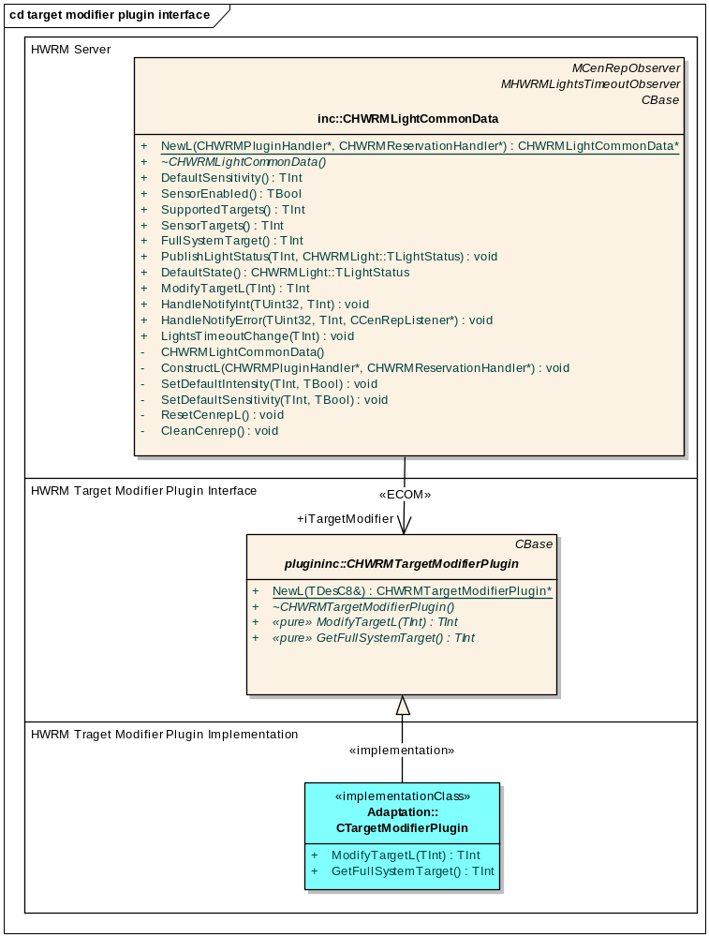
The CTargetModifierPlugin class represents the actual implementation of the plug-in that is responsible for checking the state of the HW and for modifying target accordingly. The plug-in implementation class should be derived from the CHWRMTargetModifierPlugin class that handles the instantiation of the implementation via ECom. CHWRMLightCommonData from HW Resource Manager Server creates the instance of the class CHWRMTargetModifierPlugin.

Using Target Modifier Plug-in API

Implementing HWRM Target Modifier Plug-in
To implement HWRM Target Modifier Plug-in, derive a class from the CHWRMTargetModifierPlugin base class and implement its constructor, destructor, ModifyTargetL and GetFullSystemTarget methods.
Example:
class CHWRMDefaultLightTargetModifierPlugin : public CHWRMTargetModifierPlugin
{
public:
static CHWRMDefaultLightTargetModifierPlugin* NewL();
virtual ~CHWRMDefaultLightTargetModifierPlugin();
// Method to modify target according to customer specific needs.
virtual TInt ModifyTargetL( TInt aTarget );
// Method to get full system target.
virtual TInt GetFullSystemTarget();
private:
CHWRMDefaultLightTargetModifierPlugin();
void ConstructL();
};
A DLL implementing HWRM Target Modifier Plug-in should contain an ECom factory method for creating an instance of the plug-in class. In the example below, the factory method is named NewL.
Example:
const TImplementationProxy ImplementationTable[] =
{
// Map the interface implementation UIDs to implementation factory functions.
// Allocate your own UID.
IMPLEMENTATION_PROXY_ENTRY(0x10281B9A, CHWRMDefaultLightTargetModifierPlugin::NewL)
};
EXPORT_C const TImplementationProxy* ImplementationGroupProxy( TInt& aTableCount )
{
// Exported proxy for instantiation method resolution.
aTableCount = sizeof(ImplementationTable) / sizeof(TImplementationProxy);
return ImplementationTable;
}
A class derived from CHWRMTargetModifierPlugin must provide an implementation for the ModifyTargetL method to modify target according to customer specific needs by removing currently inactive (i.e. covered or otherwise hidden or just not active for other reasons) targets from supplied mask. Modifying target must be restricted to removing unsupported elements from the supplied target. Adding new targets will result in problems with reservation handling and is therefore not supported. The method is called by HW Resource Manager when turning lights on or off, or making them blink.
Example:
TInt CHWRMDefaultLightTargetModifierPlugin::ModifyTargetL( TInt aTarget )
{
TInt modifiedTarget(aTarget);
// Modify target by removing currently inactive targets from the mask.
return modifiedTarget;
}
A class derived from CHWRMTargetModifierPlugin must provide an implementation for the GetFullSystemTarget method to modify target according to get full system target mask including system targets that are currently unavailable. This is called only once during initialization of the plug-in.
Example:
// Define system target mask.
const TInt KSystemTargets(CHWRMLight::EPrimaryDisplay |
CHWRMLight::EPrimaryKeyboard);

TInt CHWRMDefaultLightTargetModifierPlugin::GetFullSystemTarget()
{
return KSystemTargets;
}

Plug-in configuration
Target Modifier Plug-in API is implemented as a standard Symbian OS ECom plug-in. For more information about ECom plug-ins, refer to Symbian documentation.
As is usual with the ECom architecture, special care must be taken when writing the resource files. When implementing the plug-in, the resource file must implement the interface_uid of 0x10281B99, the default_data must equal HWRMLight and rom_only must equal 1. Without these conditions the plug-in implementation will not load correctly. Here is an example resource file demonstrating the correct values:
#include "ecom/RegistryInfoV2.rh"

// Declares info for two implementations
RESOURCE REGISTRY_INFO theInfo
{
// UID for the DLL. See hwrmdefaultlighttargetmodifierplugin.mmp
resource_format_version = RESOURCE_FORMAT_VERSION_2;
dll_uid = 0x10281B9B;
interfaces =
{
INTERFACE_INFO
{
// UID of interface that is implemented
interface_uid = 0x10281B99;
implementations =
{
IMPLEMENTATION_INFO
{
implementation_uid = 0x10281B9A; // allocate your own UID
version_no = 1;
display_name = "HWRM Default Light Target Modifier Plugin";
default_data = "HWRMLight";
opaque_data = "";
rom_only = 1;
}
};
}
};
}

Error handling
Possible error conditions for HWRM Target Modifier Plug-in are:
The plug-in implementation specified in the plug-in configuration resource is not found.
The plug-in instantiation fails.
The ModifyTargetL method leaves.
The plug-in is not mandatory for HW Resource Manager functionality, but the light control logic will be broken if the plug-in is not found or plug-in instantiation fails. If the plug-in cannot be loaded, targets are never modified.
HW Resource Manager leaves if the ModifyTargetL method leaves.
Errors caused by badly implemented or misbehaving plug-in DLLs (such as a plug-in implementation panicking or crashing) can not be detected by HW Resource Manager.

Memory overhead
The memory overhead is implementation dependent.

Extensions to the API
Target Modifier Plug-in API is not intended to be extended.

Further Information

References
No. | Document Reference | Version | Description
[R1] | Light API Specification Document
[R2] | Vibra API Specification Document
[R3] | Power State API Specification Document
[R4] | HW Resource Manager Plug-in Services API Specification Document
[R5] | HW Resource Manager Design Document
[R6] | HW Resources and Enhancements Subsystem Architecture Description Document

Open Issues
None.

Glossary
Term | Definition
HWRM | HW Resource Manager
Resource | In HWRM context, resource (HW resource) is a concrete HW feature that needs controlled access by multiple clients. Device vibra and lights are such resources.
System Target | A device specific set of lights targets that are controlled by e.g. user activity. Typically this includes displays and keyboards and excludes custom targets such as leds or flashlights.
Target | Target is a logical subpart of a HW resource. E.g. lights resource has primary display and primary keyboard targets, in addition to others.

